本校學生暑修轉帳步驟及英文檢定相關說明
Announcement for Summer Course ATM Transfer and Verification of English Proficiency

一、暑修轉帳相關步驟說明：
I. About Summer Course Bank Transfer
- ATM轉帳：上網【元智首頁/個人Portal/教學務/選課系統/暑修（加選學分、繳費單）】，依畫面顯示之暑修繳費單上所列之繳費帳號，於規定繳費期限前透過各銀行ATM（貼有自動跨行轉帳標誌者）將應繳金額轉入，ATM轉帳後約一小時多即可選課。輸入所需學分數，即可出現金額，利用個人專屬14碼轉帳帳號繳費(每個學生都不同的14碼轉帳帳號)
- ATM Transfer: Log in to your portal, the language setting can only be Chinese, and follow the step. 元智首頁/個人Portal/教學務/選課系統/暑修（加選學分、繳費單） Please transfer the payment to the account, which shows on your portal page. Remember the deadline of payment transfer. After the transfer, please wait for about 1 hour, you can start to select course on the system. More detailed information will be shown in the next step.

二、英文檢定相關說明：
II. About Verification of English Proficiency
- 暑修EL360 (1學分/學分費$1390)英語檢定畢業門檻補救課程；限108級大四、107級大五同學修習。
符合修課資格者，請於選課期間持英語檢定成績單及學生證至語文中心辦理修課申請。(防疫期間可受理email或通信辦理，請洽語文中心 分機3243白助教 ildept@saturn.yzu.edu.tw)
- The Summer Course of Verification of English Proficiency (Course ID: EL360), can only selected by Grade108 Senior and Grade107 Delay Graduation Student.
If you meet the requirement, please take your student card and Verification of English Proficiency Transcript to International Language and Culture Center during summer course select period. Application by email and phone call would be allowed. For further information please call 03-4638800, ext. 3243 or send an email to
ildept@saturn.yzu.edu.tw).
- 英語檢定(EL360)暑修第一期選課注意事項如下：(繳費、選課時程詳見課務組公告)
1.暑修選課路徑：元智大學首頁→選課系統
2.暑修選課步驟：預約學分數→查詢轉帳帳號→ATM轉帳→確認轉入金額→選課
※暑修預約學分數路徑：個人portal/教學務/選課系統/暑修(加選學分、繳費單) 請於暑修選課截止日前至語文中心填寫【英語檢定修課申請表】並繳交【英檢成績單】；才算完成程序。
國際語言文化中心 啟
- Important information about Course of Verification of English Proficiency (Course ID: EL360) , Phase I, are mentioned below: (For payment and application period, please refer to the announcement of Curriculum Section.)
- How to select summer course: Portal → Elective System
- The order of summer course selection: Choose your credits → Check the account, which you will transfer → Transfer the payment → Check the transfer is complete or not → Select the course
※How to choose your credits: Portal/教學務/選課系統/暑修(加選學分、繳費單), please submit your Verification of English Proficiency Transcript and complete the form of “Application of Verification of English Proficiency Course” to International Language and Culture Center during summer course select period.

International Language and Culture Center
-----------------------------------------------------------------------------------------------------
三、暑修ATM轉帳步驟說明：
III. The Step of ATM transfer for Summer Course.

步驟一：免到校註冊系統
Step 1: Enter the system of Off-campus Registration.
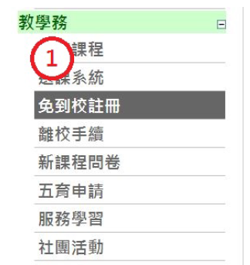
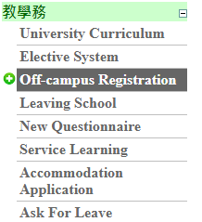
步驟二：暑修(加選學分，繳費單)
Step 2: Summer Course (Setting the Tuition per credit hour)
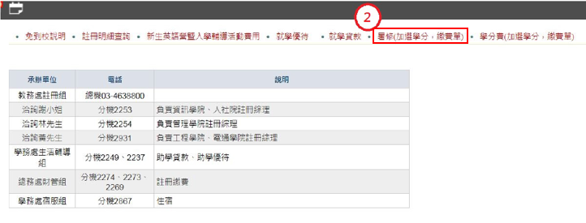

步驟三：輸入所需學分數，即可出現金額，利用個人專屬14碼轉帳帳號繳費(每個學生都不同的14碼轉帳帳號)
Step 3: Select the credits of the course you have applied for. The system will count the payment for you. Please transfer to your personal account (each student has their own 14 number transfer account).

※學生跨系選修課程之收費標準依開課班級之收費標準收取（依教育部台（九０）高（四）第九００三七一一四號函辦理）。即若管理學院學生選修工程學院課程，應以工程學院學分費為繳納標準。
※If Student select the course of other department, the tuition fee standard should follow the course offer department. (According to the Regulation of Ministry of Education.) For example, students from the School of Management who choose courses from the School of Engineering should pay the School of Engineering credit fee.
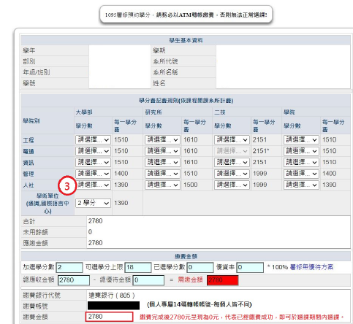

步驟四：繳費成功後出現下面畫面代表已經轉帳成功
Step 4: After payment, if your page is the same as the one below, this means that the transfer has been successful.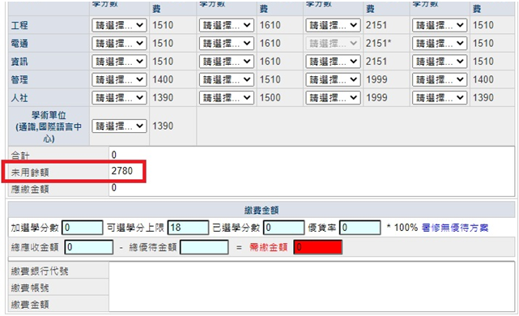

步驟五:選課期間才可查詢到以下畫面，即可選課。
Step 5: Student can only enter the system during course selection period. Please check the page is the same as the one below.
