兩階段電腦抽籤Q&A
Computer Random-Selection Q&A

Q1：我為何沒優選抽籤資格？(Limited to the students with course selection priority)
A1：舊生需填答完成上學期(1111期末問卷)加這學期(1112期初問卷)所有課程之問卷，請由學生「個人PORTAL/學習檔案/優選資格」，下拉需選課之學期(1121學期)確認。如下畫面：
Students need to fill in questionnaires, including semesters (1111&1112). Please follow the path “Portal /Academics/Enrollment Confirmation/Semester (1121) to confirm the course selection priority.
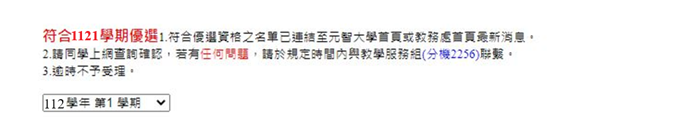
※對於優選資格如有疑問，請電詢教學服務組03-4638800(分機2256)。
If any students have questions, you can contact 03-4638800(Extension Number 2256).

Q2：為何有些課程無法抽籤？ Exceptions of Computer Random-Selection
A2：第一階段抽籤只有【通識和選修】課程需抽籤，其他課程如：必選修、必修、共同必修等，需至第二階段抽籤才會與通識、選修課程之剩餘名額再次開放抽籤，請至個人portal訊息公告、元智首頁訊息公告、教務處首頁最新消息或e-mail公告，查詢連結檔案，課程註記如下畫面(優選生須抽籤課程打勾)才可抽籤。
In computer random-selection (Phase I), students only need to draw the courses in general education and elective courses. Other courses included compulsory and elective courses would be drawn in computer random-selection (Phase II). Please confirm checkboxes are checked by Portal / YZU homepage / Office of Academic Affairs /e-mail.
範例：
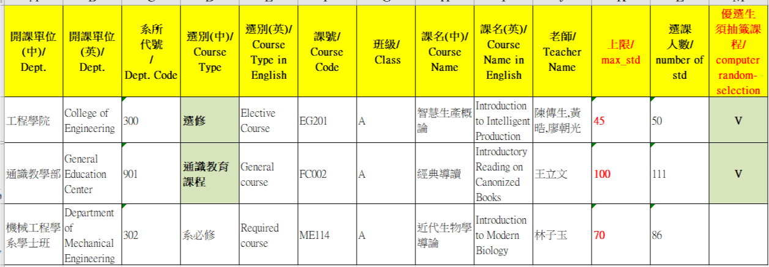

Q3：第一階段抽籤優選釋放多少名額？
In Computer random-selection (Phase I): How many quota of students can draw courses.
A3：【優先選課實施方式說明】Measure of course selection priority
1. 選課優選名額：The quota of course selection priority
* 修課人數上限為35人(含)以下之選修課程，保留5個名額；(Those courses in which the maximum number of students are 35 students. The quotas of course selection priority are 5 students.)
* 修課人數上限為36～70人之選修課程，保留10個名額； (Those courses in which the maximum number of students are 36~70 students. The quotas of course selection priority are 10 students.)
* 修課人數上限為71人(含)以上之選修課程，保留15個名額給填完所有網路問卷的學生優先選課
(Those courses in which the maximum number of students are 71 students. The quotas of course selection priority are 15 students.)
2. 以上說明僅限【通識和選修】課程。The above description is limited to the courses in general education and elective courses.
3. 剩餘名額會於第二階段抽籤再釋出，請記得於第二階段抽籤期間再次抽籤。
Surplus quotas will release in computer random-selection (Phase II). Please remember to draw again in computer random-selection (Phase II).

Q4：若未參與電腦抽籤？ If individuals do not attend the computer random-selection?
A4：第一階段若未參與電腦抽籤，剩餘名額會於第二階段抽籤再釋出，請記得於第二階段抽籤期間再次抽籤，否則視同放棄選修該科目。
If you did not attend the computer random-selection (Phase I), those surplus quotas will release in computer random-selection (Phase II). Please remember to draw again in computer random-selection (Phase II).

Q5：如何確認已選上？ How to confirm the result?
A5：學校統一於抽籤結束後進行抽籤註記，如下畫面：The resulting picture is as follows
【已選上】恭喜您已選上，不用再做第二階段抽籤。The blue words mean that you take the course.
【數字碼】表示您未抽上，請記得於第二階段抽籤期間再次抽籤。The black number means that you fail to take the course. Please remember to draw again in computer random-selection (Phase II). (課程抽籤時皆會出現數字碼，抽籤結束後課務組進行抽籤註記，您就會知道有否抽到)
【尚未抽籤】表示您忘記上portal抽籤，第一階段若未參與電腦抽籤，剩餘名額會於第二階段抽籤再釋出，請記得於第二階段抽籤期間再次抽籤，否則視同放棄選修該科目。
The green words mean you didn’t draw in computer random-selection. If you did not attend the computer random-selection (Phase I), those surplus quotas will release in computer random-selection (Phase II). Please remember to draw again in computer random-selection (Phase II). If individuals do not attend the computer random-selection, it will be regarded as disclaiming the course selection.
範例：
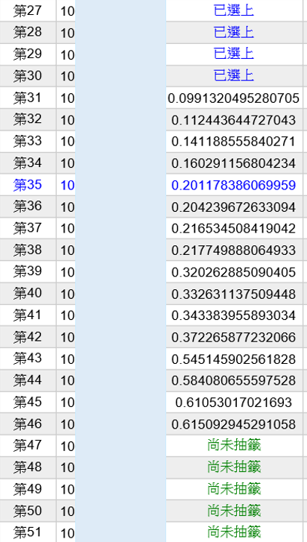
尚未抽簽
數字碼
已選上

