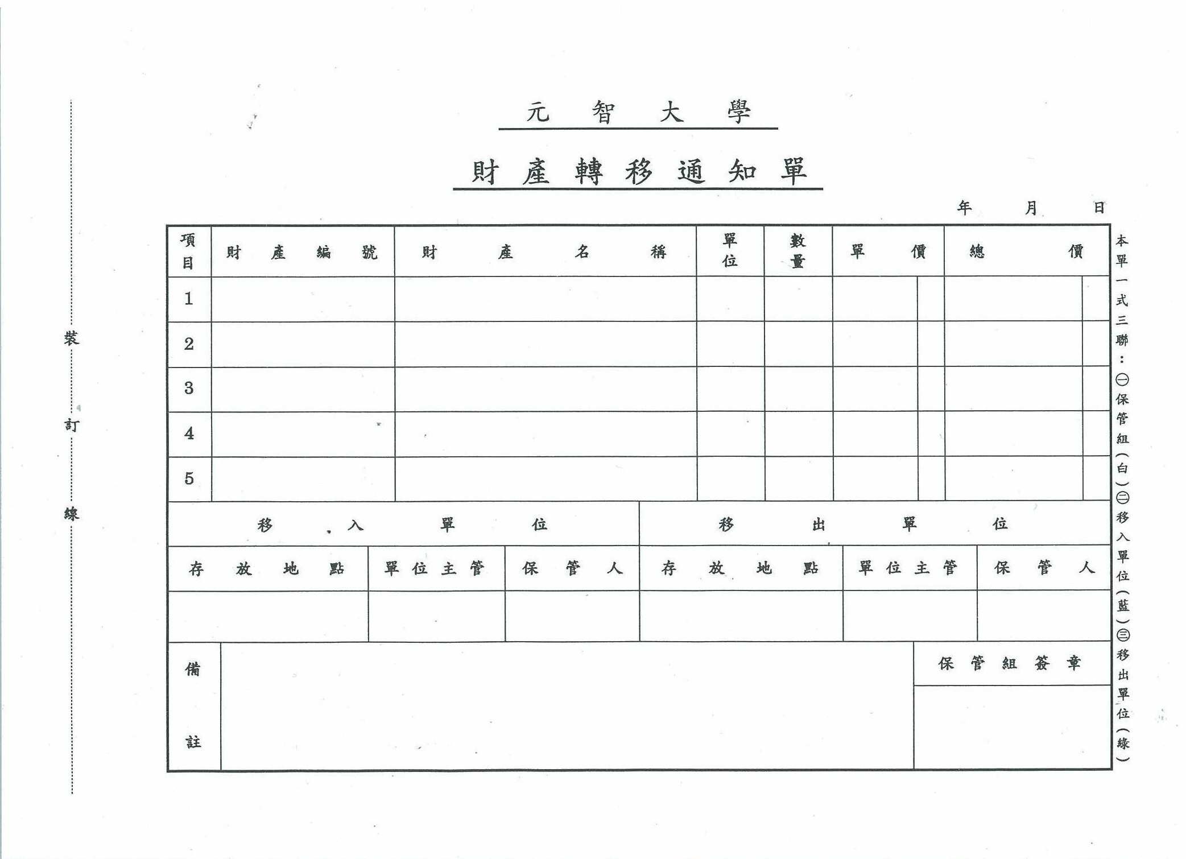
GA-CP-11-CF01(1.1版)/101.10.25修訂

