元智大學暑修轉帳步驟Yuan Ze University Summer Course ATM Transfer

暑修轉帳相關步驟說明：
About Summer Course Bank Transfer
- ATM轉帳：上網【元智首頁/個人Portal/教學務/選課系統/暑修（加選學分、繳費單）】，依畫面顯示之暑修繳費單上所列之繳費帳號，於規定繳費期限前透過各銀行ATM（貼有自動跨行轉帳標誌者）將應繳金額轉入，ATM轉帳後約一小時多即可選課。輸入所需學分數，即可出現金額，利用個人專屬14碼轉帳帳號繳費(每個學生都不同的14碼轉帳帳號)
- ATM Transfer: Log in to your portal, the language setting can only be Chinese, and follow the step. 元智首頁/個人Portal/教學務/選課系統/暑修（加選學分、繳費單） Please transfer the payment to the account, which shows on your portal page. Remember the deadline of payment transfer. After the transfer, please wait for about 1 hour, you can start to select course on the system. More detailed information will be shown in the next step.

步驟一：免到校註冊系統
Step 1: Enter the system of Off-campus Registration.
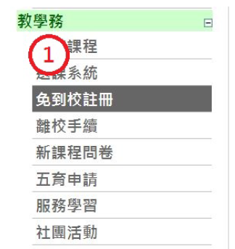
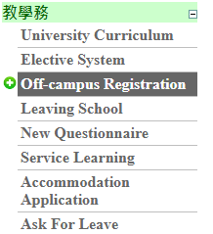
步驟二：暑修(加選學分，繳費單)
Step 2: Summer Course (Setting the Tuition per credit hour)
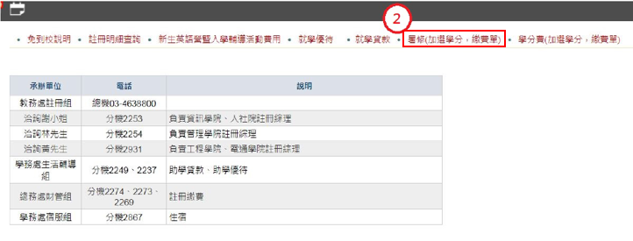

步驟三：輸入所需學分數，即可出現金額，利用個人專屬14碼轉帳帳號繳費(每個學生都不同的14碼轉帳帳號)
Step 3: Select the credits of the course you have applied for. The system will count the payment for you. Please transfer to your personal account (each student has their own 14 number transfer account).

※學生跨系選修課程之收費標準依開課班級之收費標準收取（依教育部台（九０）高（四）第九００三七一一四號函辦理）。即若管理學院學生選修工程學院課程，應以工程學院學分費為繳納標準。
※If Student select the course of other department, the tuition fee standard should follow the course offer department. (According to the Regulation of Ministry of Education.) For example, students from the School of Management who choose courses from the School of Engineering should pay the School of Engineering credit fee.
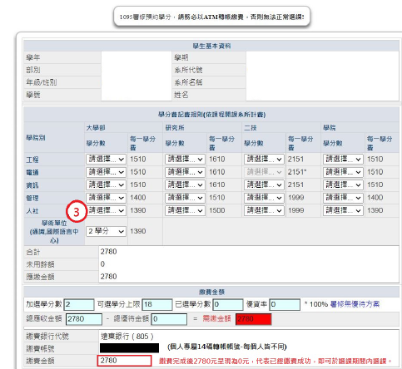

步驟四：繳費成功後出現下面畫面代表已經轉帳成功
Step 4: After payment, if your page is the same as the one below, this means that the transfer has been successful.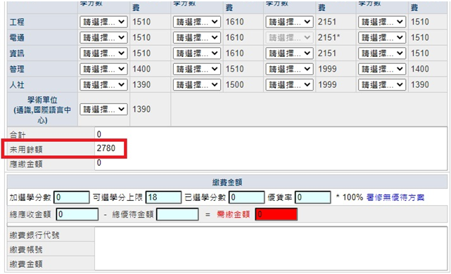

步驟五:選課期間才可查詢到以下畫面，即可選課。
112學年度新進之轉學生為確認學生有否抵免成功，不開放學生自行選課，請詳閱「暑修課暨各學系替代資訊表」並慎重考慮，於上班時間至總務處櫃台辦理繳費後或利用ATM轉帳，再請各開課單位承辦人協助轉學生辦理人工加選，一律不得申請退費。
Step 5: New transfer students in the 112 academic year are not allowed to choose courses by themselves in order to confirm whether the students have been successfully credited. Please read the " The List of Pre-Opened Summer Courses for Each Department and Substitute Course Information of 111 Academic Year
" carefully and consider carefully. After paying at the counter of the General Affairs Office during working hours or by ATM transfer, then ask the organizers of each course offering unit to assist the transfer students in manual addition. Cannot apply for refund.
