個人PORTAL/學習檔案/跨領域學程，可查詢學程所剩科目與通過情形。

選修學程清單之「狀態」，僅供參考，實際以各學程承辦人員審查結果為準，
如有疑問請洽各學程承辦人員，承辦人員聯繫方式如附件所示。
Students can check the remaining subjects and passing status of the course through the path (PORTAL/Learning Files/Interdisciplinary Program). The "Status" of the elective course list is just for reference only. The actual results should follow the program responsible person.
If you have any questions, please contact the program responsible person. The attached is the contact information of program responsible person.
(一)
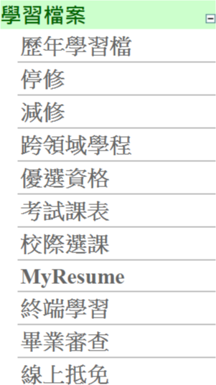
學生個人 PORTAL/學習檔案/跨領域學程PORTAL/Learning Files/Interdisciplinary Program

(二)
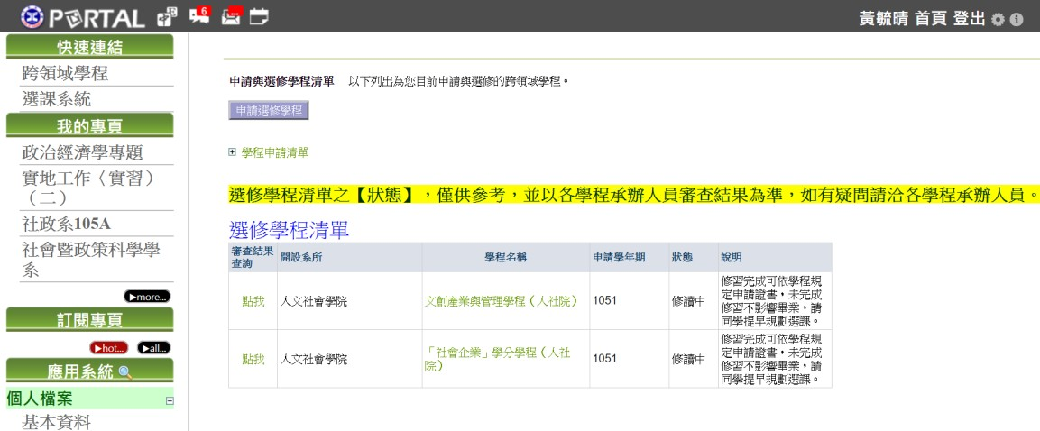
學生點選「審查結果查詢」(點我)
Click the bottom “點我”to check the application results.

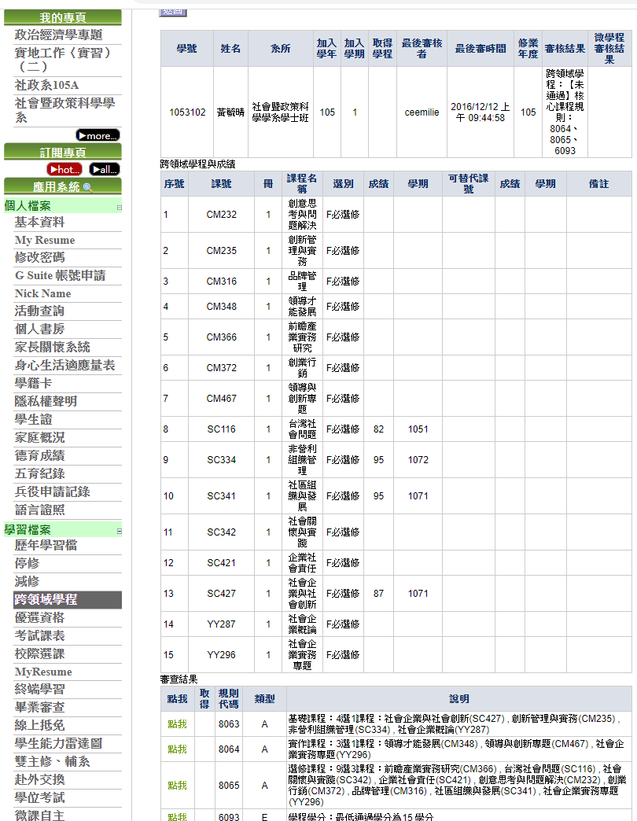

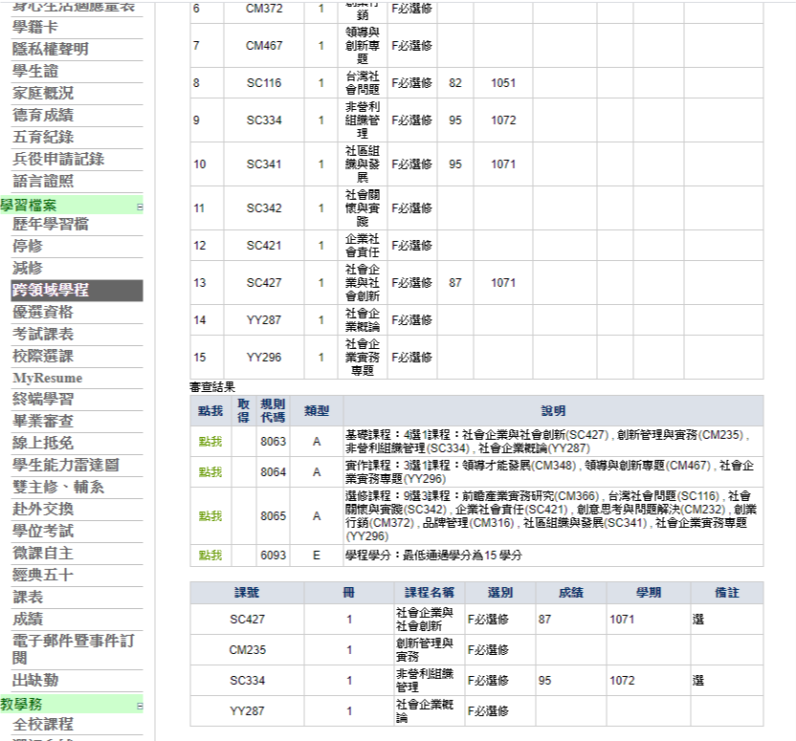
依序按”點我”即可知每個學程規則通過情形
Click “點我”to check the rule of course passing.

