Mandatory Student
Step 1. Center for Taiwan Academic Research Ethics Education. Website: ethics.nctu.edu.tw . After entering the Research Ethics Education Center website, Please select “English”.

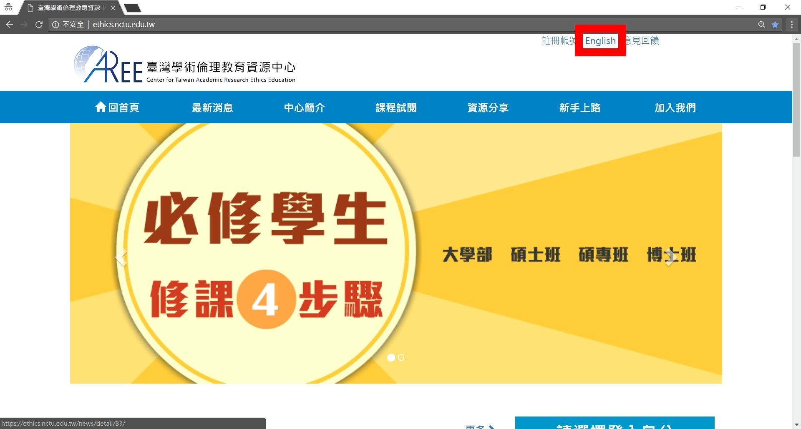

Step 2. After entering the Center for Taiwan Academic Research Ethics Education website, sign in from the right side. Please select “Mandatory Student”, your school and enter your student ID as account name. The default password is the last 5 digits of your student ID.

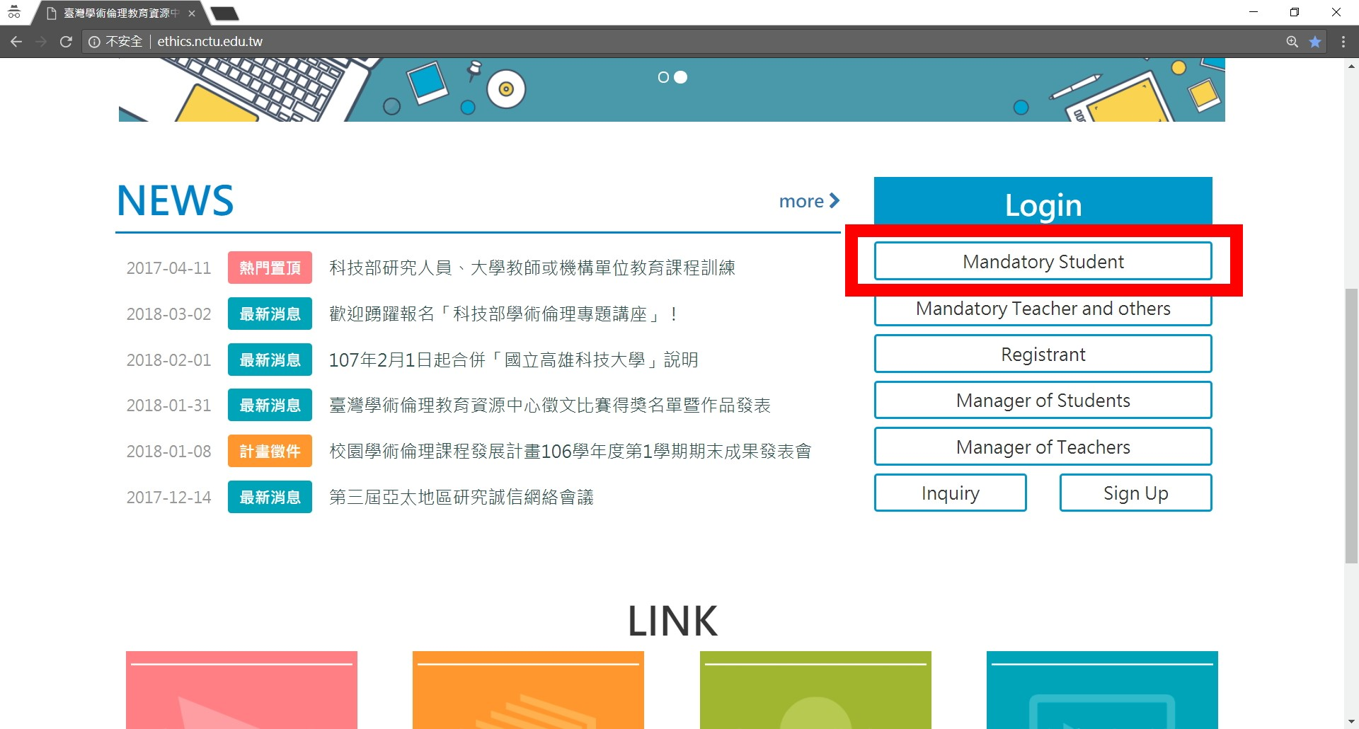

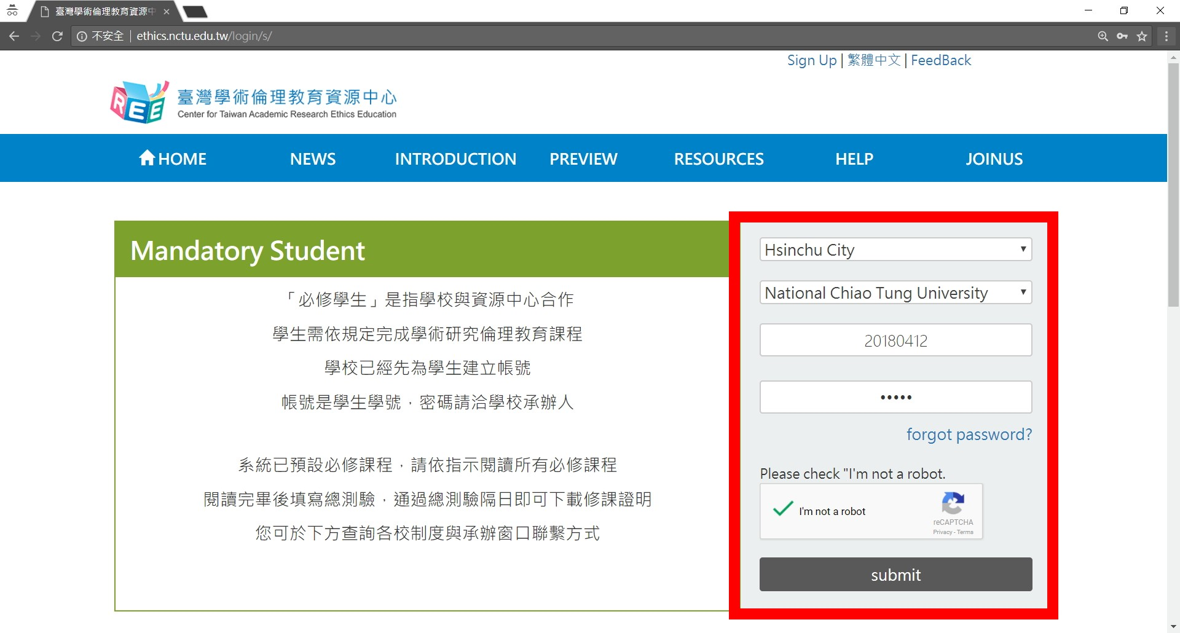

Step 3. After logging in, if you need to change your password or E-mail address, you may do so by selecting “Account” from the top of the page. If you wish to start classes, please select “Courses”→”My Courses and Exam”, and you may browse through the Research Ethics Education Online Program.

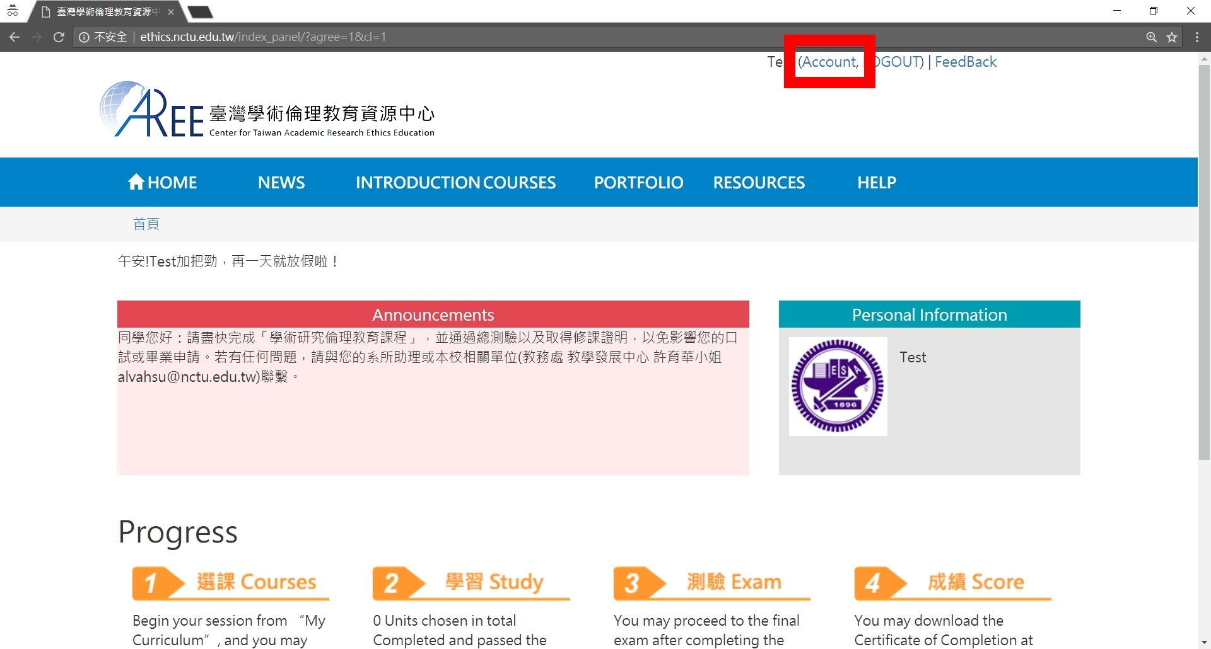

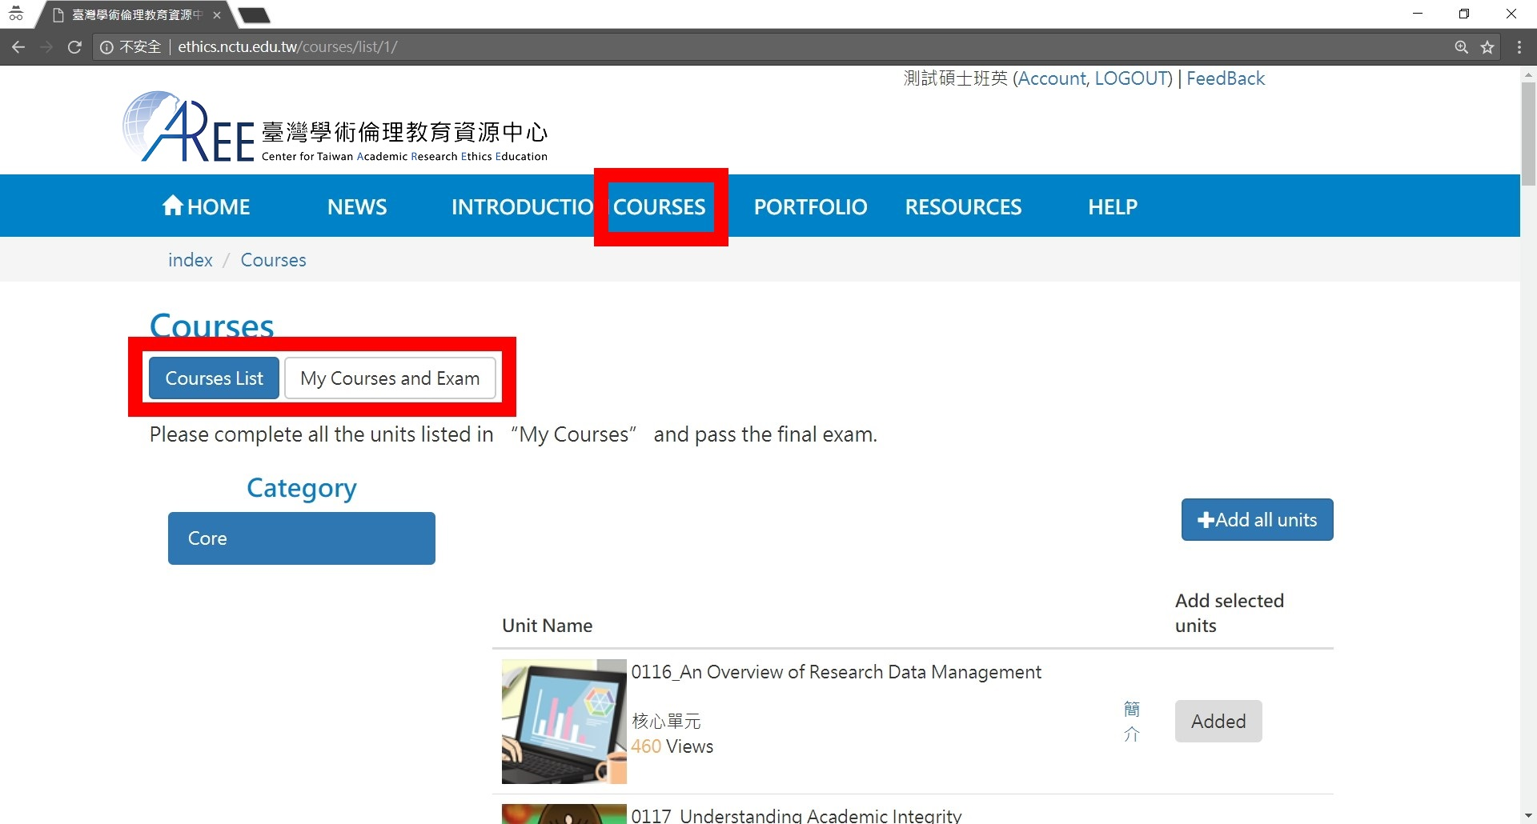

Step 4. After you have completed all core unit(s), you may proceed to the course final exam in “My Courses and Exam”. Please select “Exam” to proceed.

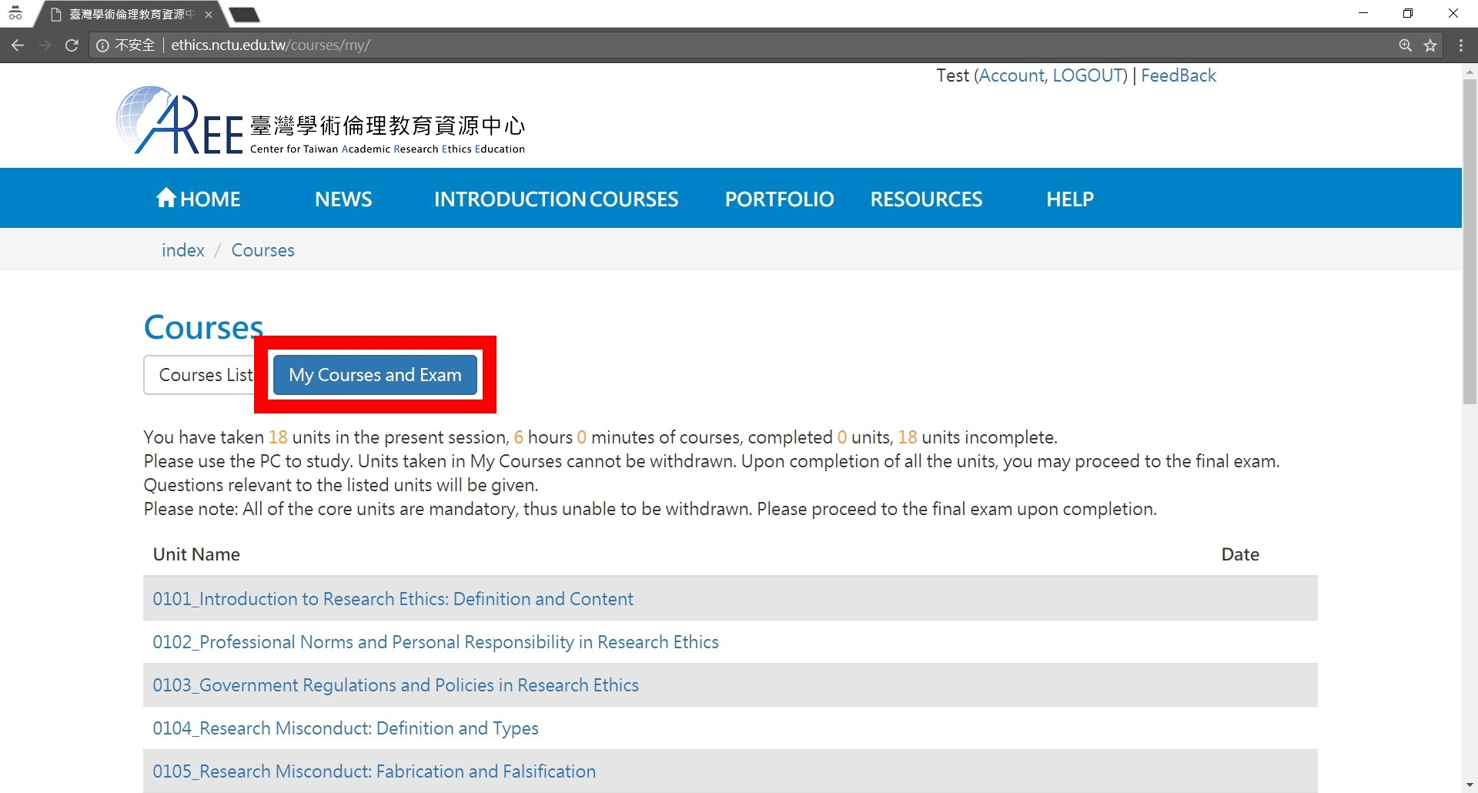

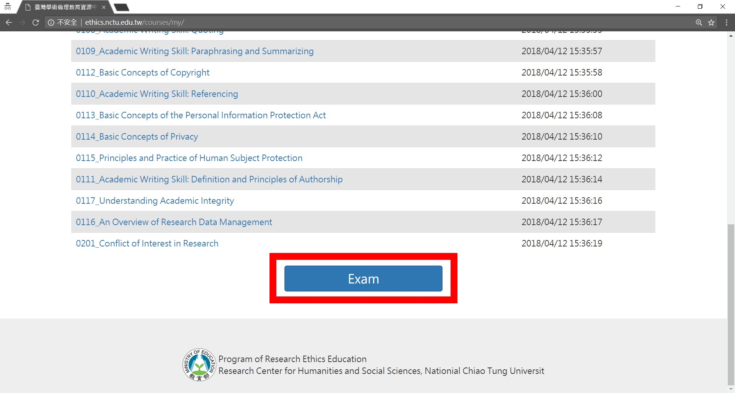

Step 5. Note: Should you leave the page while taking the exam, your answers will not be scored, and you must start over.

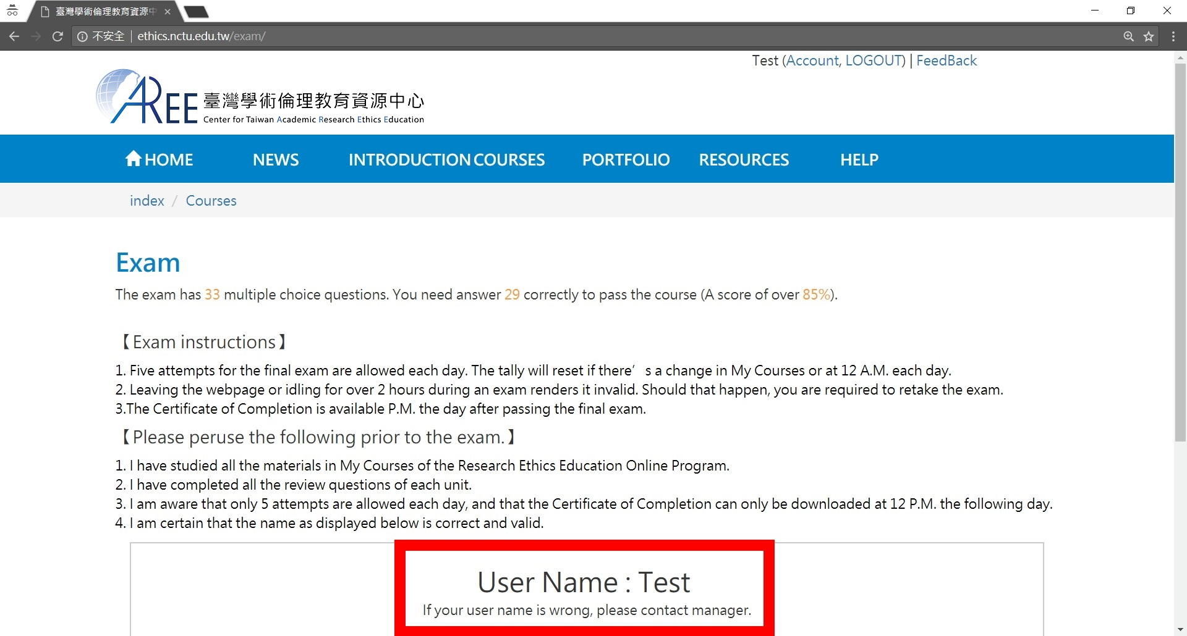

Step 6. Course final exam is consisted of single choice test items with four choices. You have unlimited attempts before passing the exam. Upon completion of the final exam, information such as number of correct answers, percent correct, and etc. will be displayed.

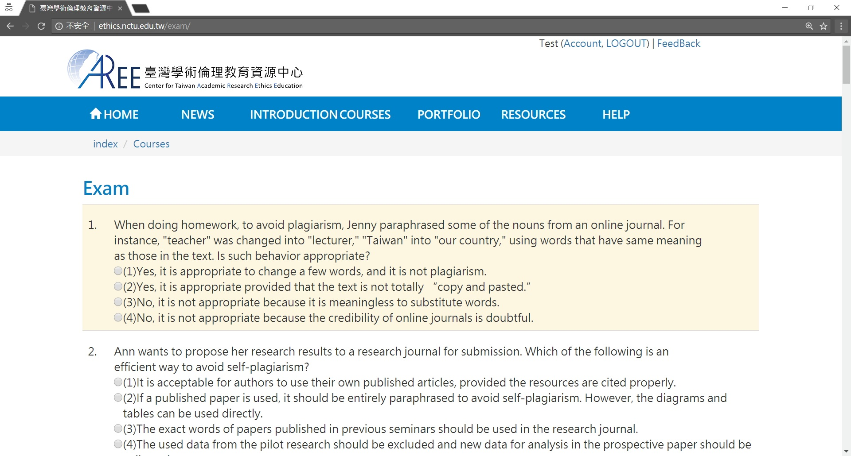

Step 7. If you pass the course final exam, after 12:00 PM, the next day after passing unit(s) exam, “Download” for Certificate of Completion will appear in “Portfolio”. You may select it and save as a PDF file.

