Where can you go to obtain program details If you want to find information about a program.

①The Office of Academic Affairs website has a link to the introduction of school-wide interdisciplinary programs：

( location: Homepage→ office of academic affairs→ Students’ Resource→Application Program→ The List of Interdisciplinary Course Program)

<https://www.yzu.edu.tw/admin/aa/index.php/tw/2016-01-14-06-58-46/2016-03-13-13-02-53/interdisciplinary-course-program>

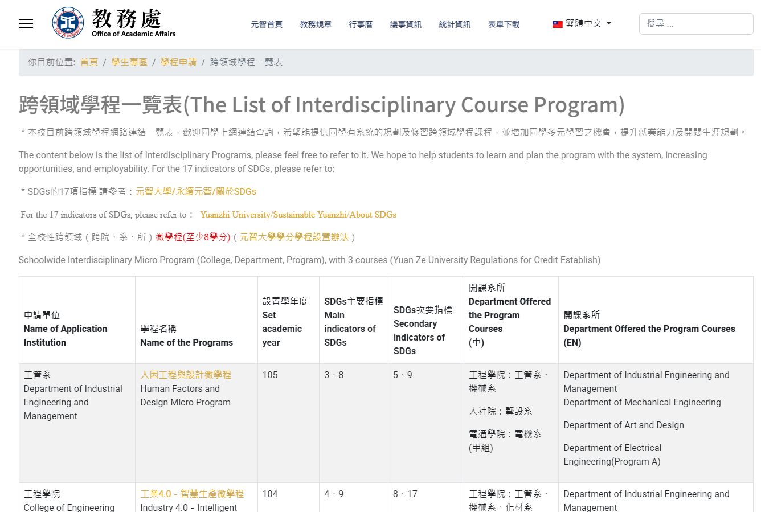

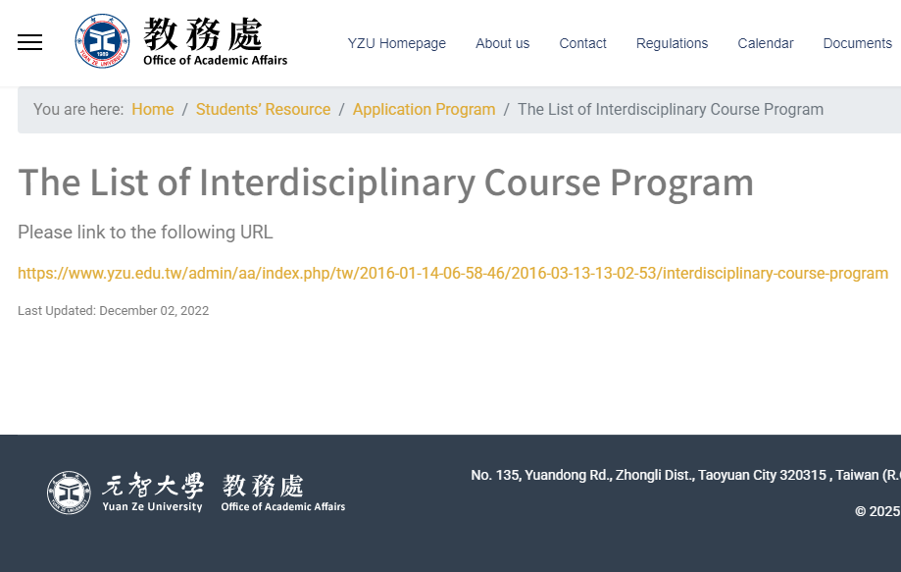

②You can find information about various program courses under "Course Information."：

(Homepage→ Portal→ Course Selection→ Course Selection System→ Yuan Ze University - University Curriculum)

<https://portalfun.yzu.edu.tw/cosSelect/Index.aspx>

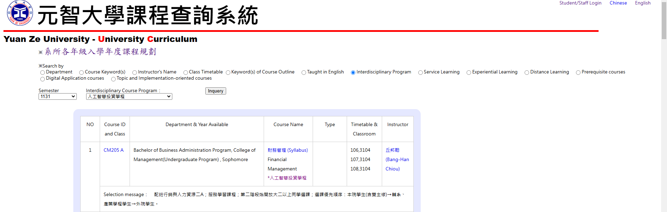

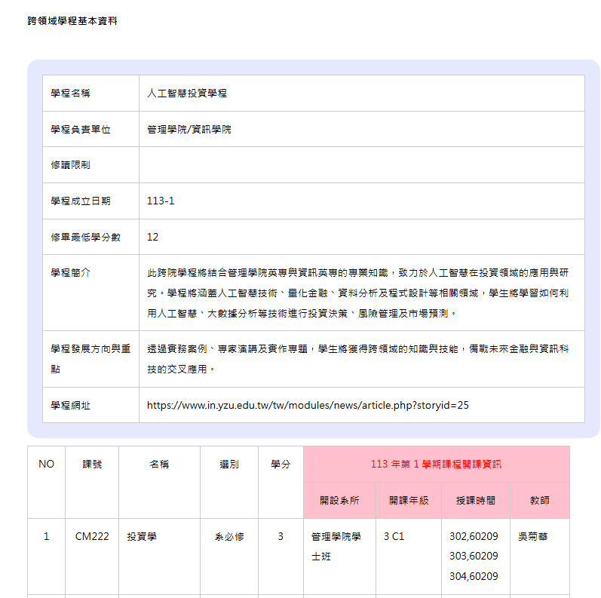

③How to apply for a program online?

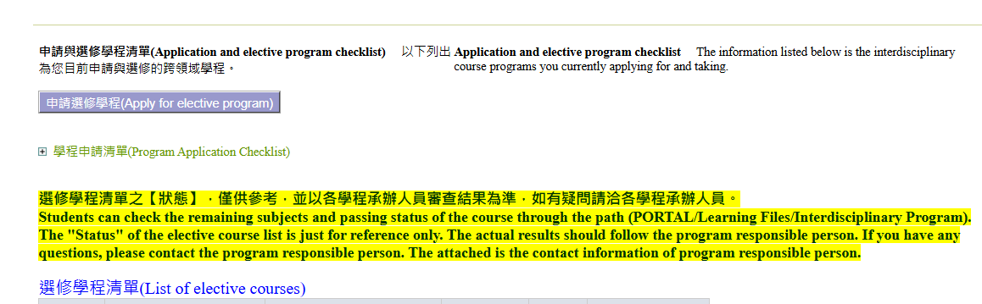

1. **Click** **Apply for elective Program**

**(Portal  learning profile Interdisciplinary program)**

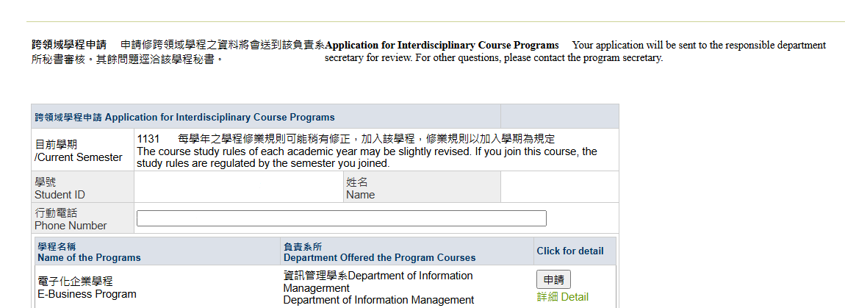

**2.1**

**Students can click 'Apply' for the program they intend to enroll in.**

**2.2**

**The secretary, please select 'Agree' or 'Disagree' under the secretary's approval.**

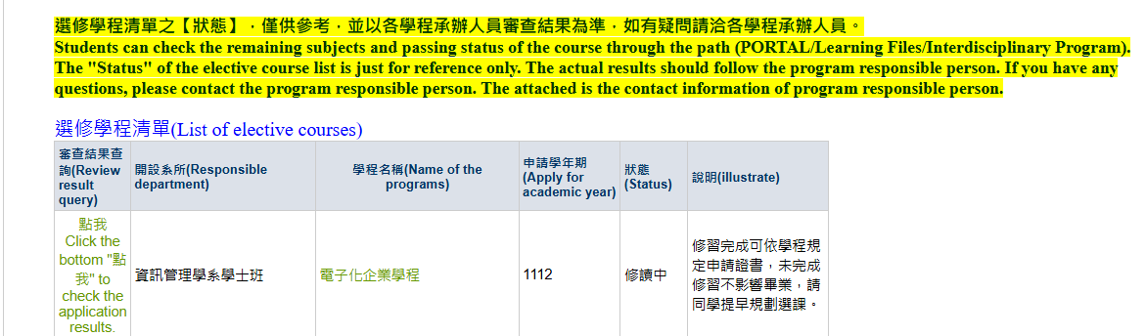

**3.** **Once the program secretary agrees that the student should take the program, it will appear on the elective program list. Click "Click Here" in the review results query, which will bring up the course years and grades the student has taken.the student has already completed.**

