Ball Grid Array surface defect inspection and classification using machine vision

Bernard C Jiang¹ Chien-Chih Wang² Chien-Cheng Chu¹

¹ Department of Industrial Engineering and Management, Yuan-Ze University, Taiwan
² Graduate School of Engineering Management, Ming-Chi University of Technology, Taiwan

ABSTRACT

BGA (Ball Grid Array) surface defect detection requires faster and more accurate methods for semiconductor industry applications. Traditionally, the BGA inspection used gray-scale images. However, the solder pad, wiring and gray scales shown in images depict little variance. Therefore, when the threshold value is poorly set or the contract rate is insignificant, BGA detection may fail to segment an object. This research proposes a modified methodology that uses gamma correction for image enhancement. Three color bands are applied to a modified gamma correction algorithm, (i.e., RGB) to better separate the high and low image contrasts. Better results are obtained by dividing the image into background and foreground portions using the Gamma correction and the R color band. As a result, the proposed method can improve the contrast value by about 52.09%. The eigenvalues of the shape and non-uniform features are used to detect defects. The results showed that classification correctness research 96.43%. The proposed method was used with a 640×480 pixel image, performing complete defects detection 0.3 seconds faster than the traditional enhancement method, which requires 1 second. The research results provide an effective solution for the detection and classification of the BGA surface tin ball defect problem.

Keywords： RGB、Gamma correction、Image enhancement、Defect detection

1. Introduction
Traditionally, the BGA detection uses gray scale images for defect identification. There are differences in the gray scale values present in an image due to the welding pad, wires, and substrate. Therefore, when a poor critical value or small degree of contrast exists, the defect objects in the image cannot be segmented. To improve the current BGA detection problem, this research presents a novel segmentation procedure aimed at defects on the BGA surface tin ball and circuits. As a result, the defect and background areas can be speedily segmented.
Applying machine vision to BGA or PCBs detection has been a topic of recent research (Moganti et al. [10]; Wang and Jiang [13]; Jiang et al. [6], [7], [8]; Yeh and Tsai, [14], [15]; Yen and Tsai [17]). Yeh and Tsai [14], [15] proposed boundary based corner detection method using covariance matrix eigenvalues to detect boundary defects. Yen [16] proposed a 2D wavelet-based procedure for detecting open and short defect candidates on BGA substrate conduction paths. Yeh [14], [15] uses an LCD-based phase measuring techniques that can perform 3D measurement of BGA solder ball in an area. Chiu et al. [1] completed a set of BGA gold- plating detection methods and classification system that could detect four kinds of defects, scrapes, pinholes, pollution and green paint in the BGA gold-plating area. Because normal tin ball pad welding fingers have a particular color, an excrescent phenomenon appears in the color that changes the items appearance. Techniques such as the applied color space model conversion and color image segmentation may detect the possible defects. Characteristic sampling, characteristic analysis, and neural network classification can then be used to classify the defects. The findings show that BPN network training produces better BGA gold plating area detection and classification. However, the detection and classification speed are not fast enough. Independent segmentation is also not available in this method. Lin et al. [5] applied a computer vision technique and improved the SOM network to carry out BGA and defect detection measurements. The basic structure of their system involved capturing the BGA Original image, and using color pixels with a neural network to optimize the image segmentation. The image processing technique was then used to detect the BGA- construct solder ball diameter, solder ball roundness, density, ball deviation, ball distance, double balls, and any damaged or missing balls. The main purpose is to eliminate non-solder ball images and undesired signals from the BGA image. The complete BGA image will be detected using block marking, block pixel edge analysis to locate the solder ball coordinates. Error margin and signature error minimization are utilized to calculate if the size, radius, ball distance, area, roundness are close to the standard values. Finally, related coefficient selection should work together to detect if any defects exist the solder ball density. However, this method involves a comparison and is unable to carry the calculation template needed.
The traditional image enhancement process involves selecting a suitable color mode for enhancement processing (Gonzalez and Woods [3]). The research proposes a modified methodology that uses gamma correction to replace the traditional image enhancement process. Gamma correction is often designed for electrical circuits to correct the screen display contrast (Gonzalez and Woods [3]). When the contrast is incorrect and slightly bright or slightly dark, the Gamma corrected circuit carries a tiny adjustment that can make the screen contrast value return to the desired status. Gamma correction conducts a non-lineal conversion based on multiplication. In the application, Gamma correction is normally used to correct images or video. Kleihorst et al. [4] designed a Gamma spatio- temporal order correction statistic for digital cameras. This “shelter operation” helps the digital camera decipher poorly regulated contrast signals when pictures are taken. Farid [2] proposes "a blind estimation method” that uses no reference samples or information. This technique is used to provide reasonable Gamma correction. The distribution of Gamma values in several natural images was used conduct a statistical correlation to determine the approximate positions of the Gamma values, ranging between 0.4 to 2.2 for comparison and correction.
In recent years many scholars proposed various segmentation methods (Gonzalez and Woods [3]). The common effective segmentation methods, the Otsu and Entropy methods, utilize statistics for segmentation. Images are segmented into two groups to determine a value that is the sum of the variables. This value serves as the best segmentation point. Other methods utilize Entropy to define the segmentation values. However, both methods have higher time complexity. Zhang and Hall [18] developed a method suitable for images with numerous features. They used segmentation and labeling to design a set of systems which can be trained to maintain the images and correlate the territories. and compare whether there are differences in any parts. A genetic algorithm is used to conduct system training for segmentation. It was found that multiple districts in a picture can be labeled and segmented allowing multiple segmentations. However, some scenes may temporarily become misty, but good segmentation is produced from a large territory. Jiang and Yang [8] used a genetic algorithm to conduct segmentation by merging the Tabu and genetic algorithms to conduct several searches to get the optimum segmentation result. Because the cell segmentation usually comes across the weak contrast problem, transitional segmentation is unable to acquire clear images. The optimum solution obtained using this algorithm is clearer and more precise cell image segmentation.
Traditional BGA inspection uses gray-scale images (Yen and Tsai [14], [15]; Lin and Chang [5]; Chiu et al. [1]). However, the solder pad, wiring and gray scales shown in image have little variation, so that when the threshold value is poorly set or the contract rate is insignificant, the system may fail to segment an object. The traditional image enhancement process selects a suitable color mode and then proceeds with enhancement. In this research, a modified methodology is proposed that uses the gamma correction in place of the traditional image enhancement process. This research explores two image enhancement aspects: increasing or improving the degree of contrast in the image and removing undesired signals to highlight the image detection area.
2. Methodology
A novel set of algorithms were developed in this research to conduct enhancement and segmentation, promote the accuracy and efficiency BGA surface defects detection and classification. This research process is shown in Figure 1.
Figure 1. in here.
Various in color model definitions have different ways of handling image information. These variations can even highlight the color information. The following deals with the models used in this research. Better models were selected to conduct the following research. In choosing the color model, actual samples were examined using trial methods, After each color model was transformed, a 3D energy diagram was produced as shown as Figure 2.
As shown in Figures 2,2(4), 2(7), 2(9) and 2(10), the high and low contrast areas in the energy diagrams were not significant. This study therefore decided not to use these color modules to conduct the analysis to explore comparisons, as discussed in 2(5). In this paper, the color models used in all experiments were R, G in RGB; H, S in HIS, and Y in YIQ.
Figure 2. in here.
Table 1. in here.
The most common image enhancement contrast method is Histogram Equalization. In this method a bar chart is transformed into an evenly distributed state based on the variables transformation principle. That is, in cooperation with a particular probability and distribution function, a low-contrast histogram is transformed into an extension, to separate the image into wide contrasts and highlight the target object. This research used five different probability distribution functions, as shown in Table 1.
We find that the Exponential and Rayleigh distributions and R, G, S and Y combination can draw apart the target and the background contrast significantly. In addition the Hyperbolic logarithmic distribution working with R can also produce a good result. The high and low contrast areas are not significant. Afterwards, it cannot support enough information to distinguish the ready-to-detect area from the background; therefore, this research will not do analysis and make comparisons for their combinations. The exponential and Rayleigh distribution parameter are all set to 1. The Exponential and Rayleighs parameters were distributed in cooperation with the R color band in these experiments.
In the following discussion, the segmentation and combination methods are used for analysis, The color model is used in cooperation with R, G and YIQ in RGB, and Y in YIQ, and Exponential, Rayleighs and Hyperbolic logarithmic distribution.
  - Using Gamma correction to enhance image
This research is an application of the Gamma correction to conduct color BGA image enhancement. Gamma correction is based on a non-liner multiplication based conversion (Gonzalez and Woods [3]).
s = output value; c = Enlargement multiplication, a constant; r = Original value; g = Gamma correction parameter.
To make Gamma correction for the three RGB values, c is the magnification rate, 1 is set for all values. The sample diagrams in Figure 3, show that after a certain parameter, it can a stable and fixed segmentation result can be obtained, the gold-surface part is independently shown and the background portion is shown as black. Thirty-two samples supplied by the manufacturer were tested, achieving a 100% result.
Figure 3. resulting here.
In view of this analysis result, a 3 D energy diagrams or color histogram was used to make the detection. In general, the image enhancement, variation in image contrast value was applied to make the assessments. The contrast value formula is as follows (Morrow, [11])：
= average value in image gray scale; = Gray scale value is f’s total pixel amount; M = Maximum value of gray scale in image; N = Total pixel element in image.
Figures 4, the 3D energy diagram shows that this research removes undesired signals from the image and lowers the contrast, the proposed method is effective. When divided into two clusters – a target with high brightness and a background with low brightness are produced, which proves that the proposed method gives outstanding results.
The contrast correction cannot be seen from the value obtained from the formula. On the contrary, it requires a downwards revision to produce the contrast ratio. These findings show that the color scale in this research is defined differently from others. 0 is the most dense and 255 is the lightest in color; after the background correction, the densest is toward 0 and with heavy distributions. The target object is toward 255, the lightest value with few distributions. When calculating the formula, after correction, the average value will decrease with smaller variables. When judging the contrast value produced by the formula and making corrections, a smaller value is better. In Figure 5, 16 samples are applied to measure the contrast value result. We find that the contrast values have all been improved and the improved contrast value reaches 52.09%.
Figure 4. in here.
For parameter g of Gamma correction, there is currently no set formula for a solution, however, viewing from the mutual image contrast ratio relation, a g parameter exists between the image information in high brightness and low brightness.
Figure 5. in here.
This research is analyzing trial-and-error experiment methods for average values among image groups, variations in the group, variations between groups, variations among high brightness groups and variations among low brightness groups. It was found that the average difference in the biggest groups was divided by the sum of the variables in the smallest groups, which produces a parameter closest to manual adjustment. Among them, the average difference in the biggest groups and variables in the smallest groups, with the help of RGB gray scale value information, the Otsu binary is applied to acquire the most approximate result. To increase operational speed in consideration of the previous manual adjustment parameter result, namely after a fixed parameter, the results are all the same. The acquired parameter is rounded up. The formula is as follows：
$$s={\text{cr}}^{g}$$
$g=\frac{U_{W}}{σ_{W}^{2}};U_{w}=(U_{l}−U_{h})^{2}×W_{h}×W_{l};σ_{W}^{2}=W_{1}σ_{1}^{2}+W_{2}σ_{2}^{2};σ_{h}^{2}=\sum_{i=T+1}^{I−1}{(i−U_{h})^{2}\frac{P(i)}{W_{h}}};σ_{l}^{2}=\sum_{i=0}^{T}{(i−U_{l})^{2}\frac{P(i)}{W_{l}};}U_{h}=\sum_{i=T+1}^{I−1}{\frac{P(i)}{W_{h}}×i;}$$U_{l}=\sum_{i=0}^{T}{\frac{P(i)}{W_{l}}×i;}W_{h}=\sum_{i=T+1}^{I−1}{P(i)};W_{l}=\sum_{i=0}^{T}{P(i)};P(i)=\frac{n_{i}}{N}$
T = Segmentation critical value acquired by binary.
N= Image size
I = Gray scale or color value number
N_{i} = Gray scale or color band value i times shown in image, and
Gamma correction perform synchronous processing for each color band, For the RGB colors, the color band carries the automatic Gamma correction during parameter calculation. Shown in Figure 6, after a certain parameter, the results are all the same. The g value is obtained in a single color, and the big value among the RGB is set is a common g for proceeding with the calculation. Regardless of the gray scale value or color value used, the enhancement goal and background contrast can be achieved. The formula is shown as follows:
is the auto correction parameter of Gamma correction acquired by R color band.
is the auto correction parameter of Gamma correction acquired by G color band.
is the auto correction parameter of Gamma correction acquired by B color band .
Figure 6. in here.
  - Image segmentation
This research uses the binary method to carry on segmentation; with two kinds adopted to make comparisons. The following two sections will explain.
The Otsu algorithm is a binary segmentation suggested by N. Otsu in 1978. The basic idea depends on two conditions, Otsu considers this acceptable as long as either one of these two conditions is established, shown as follows::
- Condition 1：
,;;
T = two values acquires segmentation critical value; N = Image size; i= Gray scale or color value number; n_{i} = Gray scale or color band value i times shown in image.
- Condition 2：
$σ_{1}^{2}=\sum_{i=0}^{T}{(i−U_{l})^{2}}\frac{P(i)}{W_{1}}$;$σ_{2}^{2}=\sum_{T+1}^{I−1}{(i−U_{h})^{2}}\frac{P(i)}{W_{2}}$;;;;;
T = two values acquires segmentation critical value; N = Image size; i= Gray scale or color value number; n_{i} = Gray scale or color band value i times shown in image.
,;;
T = two values acquires segmentation critical value; N = Image size; i = Gray scale or color value number; n_{i} = Gray scale or color band value i times shown in image.
It has been found after composing the program, the condition 1 formula aim to carry on the segmentation as diagrams in this research. The average speed was approximately 0.0714 seconds for completing the treatment more faster than the condition 2 formula took approximately 0.1539 seconds.
Besides, in information theories, entropy is an average information quantity of message output; entropy means average disorder or indetermination. Kapur et al. put forth entropy method to carry on segmentation, and the main viewpoint is extremely similar to Otsu, just the threshold value is to replace with entropy. The formula is as follows：
The best threshold value T needs to satisfy $E(C_{1})+E(C_{2})$with the maximum value.
$W_{1}=\sum_{i=0}^{T}{P(i)}$,$W_{2}=\sum_{i=T+1}^{I−1}{P(i)}$,
T = two values acquires segmentation critical value
N = Image size
i = Gray scale or color value number
n_{i} = Gray scale or color band value i times shown in image
3. Experiment and Result
The main purpose of this research aims at the BGA chip gold surface and background segregation, tin balls, circuit drawback auto detection to improve manual visual detection. In this research, we use color model, Histogram Equalization and Gamma correction to enhance the target image. The following is the findings and analysis. The outstanding features of the proposed image enhancement technique is the application of BGA image without performing sample comparisons, and without being affected by image sample revolution or shift. Figure 7 show the enhancement results. The enhancement result effects are listed in sequence by height: Gamma correction automatic Gamma correction, RGB Model with histogram equalization, YIQ Model with histogram equalization; among them HSI Model is not significant in terms of enhancement, so it is not listed. For the correction part of histogram equalization, only lists the significant results.
Figure 7. in here.
From Figure 7, the enhancement applied by Gamma correction can give the image significant contrast, while that produce using Exponential and Rayleigh distributing the combination of R, G, S is less significant. It is estimated that a single color band is solely used for enhancement, different from Gamma correction with three colors doing the job, so in picture other two channels of information and corrected single color is merged, the enhancing effect has been shared, but the comparison results of various kinds of enhancing methods in Figure 7.

Figure 8.in here
A single color can get a good enhancement effect, enabling the target and background contrast to be widened. It is recommended that a single color be used to conduct segmentation. In addition Hyperbolic logarithm's distribution and cooperation with R have insignificant effect, unable to offer enough information to distinguish ready-to-detect area and background. Consequently, this research did not perform analysis and comparisons for all combinations. Among the variables, Y and Exponential, Rayleigh in YIQ did not produce stable distribution results because images in the Y channel of YIQ Model were similar to the gray scale images, resulting in a reverse effect. The gray scale image was not stable, unable to make good segmentation, while histogram equalization makes the image information lean to a certain distribution, causing an extreme result when using channel Y. Due to the unstable results, the combinations will be taken out in the following research.
Figure 9. in here.
After images are getting enhanced, segmentation technique in this research applied stronger contrast with single color band to segment the target gold-surface part in image, without conducting sample comparisons. The segmentation result is done by visual judgment on the segmented images. In terms of enhancement effect, Otsu method is better than Entropy method.
Figures 8-9 show the segmentation result using auto Gamma correction with color band treatment. As a result, the tested samples contain two groups for auto Gamma correction with color treatment and R Band. It is found from Figure 8-9, because images with high-low contrasts are enhanced by Gamma correction, most undesired points can be effectively rid of, leaving needed gold surface, yet the following few points still need attention.
- Figures 8(8) and 9(8), show a sample using two different segmentation methods. In the Otsu method, the lines marked by personnel in the defective sample can be eliminated. However, in the Entropy method, this line is left, which is estimated that the Otsu method can reasonably separate these two groups, while in the Entropy method it is vaguely segmented area in the image information. That is the difference, and in Figure 10 shows the total time needed for program calculation from enhancement to segmentation. The Otsu method is better than the Entropy method in terms of time. It is therefore recommendable to use Otsu method to do detection with more accurate results.
- Secondly, Gamma correction in cooperation with R color in doing segmentation can achieve the best result. Gamma correction with the B color band is able to eliminate arrow marking defective positions by quality control personnel for better picture recognition. However, using the B color band is not able to provide enough information to distinguish the target area from the background. This will cause poor segmentation. This research therefore no longer make further exploration and comparison for its combinations.
- Thirdly, it is found that the segmentation results of Exponential, Rayleigh distribution in RGB are not stable enough. The target objects are often cut away because of poor image enhancement, resulting in poor segmentation. It was also proven that Enhancement treatment with Gamma correction is better than that with traditional method.
After images are enhanced and segmented, the defects are detected for external roughness, tightness, internal holes and asymmetry, which aims to find out defects of images without making comparisons of samples.
Firstly discussion goes to the appearance index, we can distinguish most appearance defects with tightness degree; besides sample with internal holes, tin balls with appearance defects. The degree of tightness was larger than 1.3, so it is recommended to have tightness as one of classification indexes. Furthermore, the internal hole index defects can be sought directly and correctly. External holes are recommended as one of the classification indexes. After programming for tightness and internal holes, we find the detection rate for appearance defects is 100 %. However, according to the program, shown in Table 3, it is found that defects or correct tin ball samples can not be correctly judged. There are two types of errors, which judge correct samples as defected samples. Once again the data comparison in Tables 2 shows the samples with appearance errors have smaller value of the two scale center moment X2Y0.
Figure 10. in here.
Table 2. in here.
Table 2-3 show indexes of every item measured and classification results from typical tin ball samples.” After the program is revised, give an general judgment on appearance defects. The results showed that classification correctness research 96.43%. There is a misjudged case because a tin ball is positioned in the border, resulting in wrong information access. This method, thus, has its limitations, so try to pick up the image within, avoiding unnecessary misjudgment.
Table 3. in here.
4. Discussion
This research improves BGA gold surface and background segmentation to make auto detections of tin balls and circuit drawback to improve current visual detection. The enhancement conducted by Gamma correction can segment images with high-and-low contrasts, and Exponential and Rayleigh distributions and combination of R, G, S are not significant, which is estimated to enhance with single band, different from Gamma correction in three-color overall correction. After combining two channels of information and revising the single band information, the enhancement result will be shared. This research proposes a modified methodology that uses gamma correction for image enhancement. Three color bands are applied to a modified gamma correction algorithm, (i.e., RGB) to better separate the high and low image contrasts. Better results are obtained by dividing the image into background and foreground portions using the Gamma correction and the R color band. As a result, the proposed method can improve the contrast value by about 52.09%. In Gamma correction, working with the R color band for segmentation, the best segmentation result was obtained. In addition, the Otsu method used for grouping can obtain more complete and reasonable two-group separation. In actual application, if detected samples are numerous and the pixel and color information are complicated. The Otsu method is capable of providing a faster answer. For a great deal of detections information, the Otsu method is suggested. The traditional enhancement method was applied to a 640×480 pixel picture to carry out a complete defect detection set, requiring only one second. The Gamma correction method could be completed in approximately 0.3 seconds. For mass industry defect detection, the proposed method can save considerable time. The proposed method obtains a classification rate of 96.43%. The research results provide an effective solution for the detection and classification of the BGA surface tin ball defect problem.
References
[1] Chiu YC, Chiu PC, and Huang CJ. Application of BGA detection in gold- plating area defects and classification system. Proceedings of the PCB manufacturing & management technology, 2002.
[2] Farid, H. Blind Inverse Gamma Correction. IEEE Transactions on Image Processing, 2001, 10(10):1428-33.
[3] Gonzalez RC. and Woods RE. Digital Image Processing. New York: America/New Jersey, 2002.
[4] Kleihorst RP. Lagendijk RL. and Biemond J. An Adaptive Order-Statistic Noise Filter for Gamma-Corrected Image Sequences. IEEE Transactions on Image Processing, 1997, 6(10):1442-46.
[5] Lin HK. and Chang SY. Application of computer vision and neutral network in BGA defects detection system. Proceedings of the PCB manufacturing & management technology, 2002.
[6] Jiang BC, Wang YM. and Wang CC. Bootstrap Sampling Technique Applied to the PCB Golden Fingers Defect Classification Study. International Journal of Production Research, 2001, 39:2215-30.
[7] Jiang BC. Tasi SL. and Wang CC. Machine-Vision Based Gray Relation Theory Applied to IC Marking Inspection. IEEE Transactions on Semiconductor Manufacturing, 2002, 15: 531-39.
[8] Jiang T. and Yang F. An Evolutionary Tabu Search for Cell Image Segmentation. IEEE Transactions on Systems, Man, and Cybernetics－Part B, 2002, 32(5):675-78.
[9] Kapur JM. Sahoo PK. and Wong AK. A new method for gray-level picture Thresholding using the Entropy of the histogram. Computer Vision Graphics and Image Processing, 1985, 29:273-85.
[10] Moganti M. and Ercal F. Automatic PCB Inspection Algorithms: a Survey, Computer Vision and Image Understanding, 1996, 63(2):287-13.
[11] Morrow WM. Paranjape RB. Rangayyan RM. and Desautels JEL. Region-based Contrast Enhancement of Mammograms, IEEE Transactions on Medical Imaging, 1992, 11( 3):392-06.
[12] Otsu N. A threshold selection method from gray-level histograms, IEEE Transactions Systems, Man, and Cybernetics, 1979, 9(1):62-69.
[13] Wang CC. and Jiang BC. PCB Solder Joints Defects Detection and Classification Using Machine Vision, International Journal of Industrial Engineering, 2001, 8(4):359-68.
[14] Yeh CH. and Tsai DM. A Rotation-Invariant and Nonreferential Approach for Ball Grid Array (BGA) Substrate Conduct Paths Inspection. International Journal of Advanced Manufacturing Technology. 2001, 17:412-24.
[15] Yeh CH. and Tsai DM. Wavelet-Based Approach for Ball Grid Array (BGA) Substrate Conduct Paths Inspection. International Journal of Production Research, 2001, 39:4281-99.
[16] Yen CH. A Novel Approach Using a Tw0-Dimensional Wavelet Transform in Ball Grid Array(BGA) Substrate Conducting Path Inspections, International Journal of Advanced Manufacturing Technology, 2003, 3:223-33.
[17] Yen HN. and Tsai DM. A fast full-field 3D measurement system for BGA co planarity inspection. International Journal of Advanced Manufacturing Technology, 2004, 24:132-39.
[18] Zhang M and Hall LO. A Generic Knowledge-Guided Image Segmentation and Labeling System Using Fuzzy Clustering Algorithm. IEEE Transactions on Systems, Man, and Cybernetics－Part B, 2002, 32(5):571-582.
Figures
Figure 1. Experiment flowchart

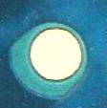
(1) Chip sample
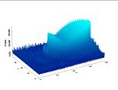 | 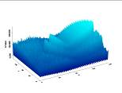 | 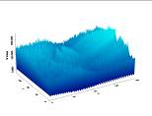
(2) R Value 3DEngergy diagram | (3) G Value 3DEngergy diagram | (4) B Value 3DEngergy diagram
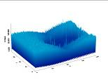 | 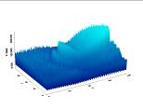 | 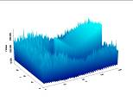
(5) H Value 3DEngergy diagram | (6) S Value 3DEngergy diagram | (7) I Value 3DEngergy diagram
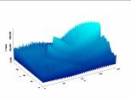 | 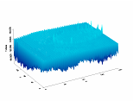 | 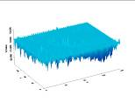
(8) Y Value 3DEngergy diagram | (9) I Value 3DEngergy diagram | (10) Q Value 3DEngergy diagram
Figure 2. Color model transformation result in compassion of energy diagrams
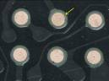  g=1 | 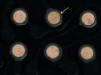  g=2 | 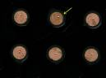  g=3 | 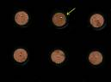  g=4 | 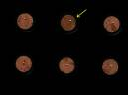  g=5
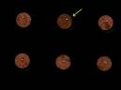  g=6 | 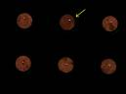  g=7 | 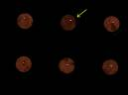  g=8 | g=9 | g=10
Figure 3. Gamma correction result

 | 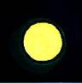
(a) Chip sample before Gamma correction | (b) Result after Gamma correction
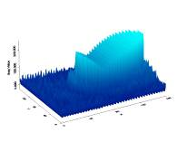 | 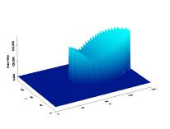
(c) 3D energy diagram before Gamma correction | (d) 3D energy diagram after Gamma correction
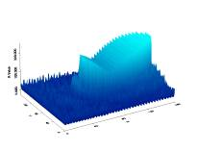 | 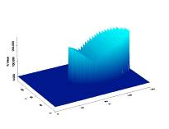
(e) R Value 3D energy diagram before Gamma correction | (f) R Value 3D energy diagram after Gamma correction
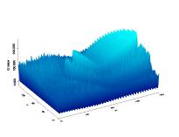 | 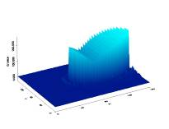
(g) G Value 3D energy diagram before Gamma correction | (h) G Value 3D energy diagram after Gamma correction
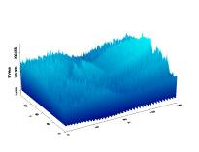 | 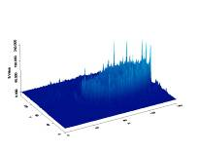
(i) B Value 3D energy diagram before Gamma correction | (j) B Value 3D energy diagram after the Gamma correction
Figure 4. 3D energy diagram before and after Gamma correction in comparison
Figure 5. The contrasts value in comparison before and after Gamma correction

(1) g value, manual adjustment result (g=6) | (2) g in application of gray scale operation (r =5) | (3) g in application of color R, G, B value operation (g =max (5,5,0,))
Figure 6. g value operational result

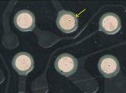 | 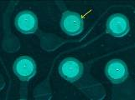 | 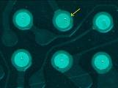
(1) Original image | (2) R Band, histogram equalization enhancement, in application of Exponential distribution | (3) R Band, histogram equalization enhancement, in application of Rayleigh distribution | (4) R Band, histogram equalization enhancement, in application of Hyperbolic logarithm's distribution
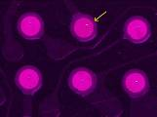 |  | 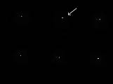
(5) G Band, histogram equalization enhancement, in application of Exponential distribution | (6) G Band, histogram equalization enhancement, in application of Rayleigh distribution | (7) Y Band, histogram equalization enhancement, in application of Exponential distribution | (8) Y Band, histogram equalization enhancement, in application of Rayleigh distribution
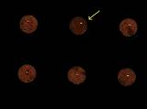 | 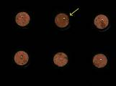
(9) Gamma correction, manual adjustment | (10) Gamma correction, auto adjustment, in application of gray scale information | (11) Gamma correction, auto adjustment, in application of color information
Figure 7. The sample group 1 enhancement results under each enhancing method

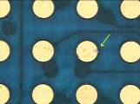 | 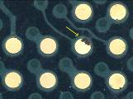 | 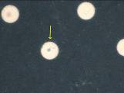 | 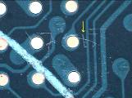
(1) Original image-1 | (2) Original image-2 | (3) Original image-3 | (4) Original image-4
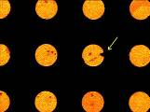 | 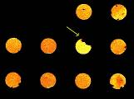 | 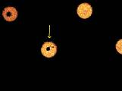 | 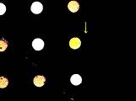
(5) Segmented image-1 | (6) Segmented image-2 | (7) Segmented image-3 | (8) Segmented image-4
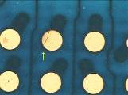 | 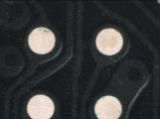 |  | 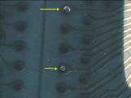
(9) Original image-5 | (10) Original image-6 | (11) Original image-7 | (12) Original image-8
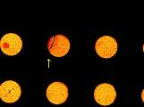 |  | 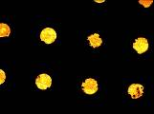 | 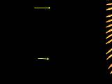
(13) Segmented image-5 | (14) Segmented image-6 | (15) Segmented image-7 | (16) Segmented image-8
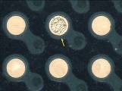 | 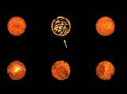 |  | 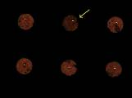
(17) Original image-9 | (19) Segmented image-9 | (18) Original image-10 | (20) Segmented image-10

Figure 8. The samples in application of auto Gamma correction, and R Band segmentation results under Otsu method

(1) Original image-1 | (2) Original image-2 | (3) Original image-3 | (4) Original image-4
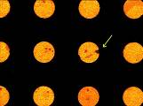 | 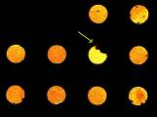 | 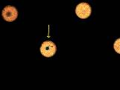 | 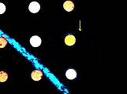
(5) Segmented image-1 | (6) Segmented image-2 | (7) Segmented image-3 | (8) Segmented image-4
(9) Original image-5 | (10) Original image-6 | (11) Original image-7 | (12) Original image-8
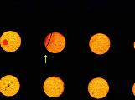 |  | 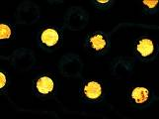 | 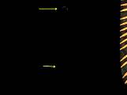
(13) Segmented image-5 | (14) Segmented image-6 | (15) Segmented image-7 | (16) Segmented image-8
 | 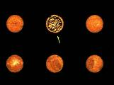 |  | 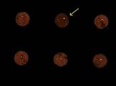
(17) Original image-9 | (19) Segmented image-9 | (18) Original image-10 | (20) Segmented image-10
Figure 9. The samples in application of auto Gamma correction, and R Band segmentation results under Entropy method

Figure 10. Boxplot of Time for Gammas correction working with every kind of segmentation (Sec.)

Tables
Table 1. Probability distribution model
function  Probability distribution | Output probability function model | Transformation function
Uniform Distribution | $$P_{g}(g)=\frac{1}{g_{\text{max}}−g_{\text{min}}}g_{\text{min}}≤g≤g_{\text{max}}$$ | $$g=\left[g_{\text{max}}−g_{\text{min}}\right]P_{f}(f)+g_{\text{min}}$$
Exponential Distribution | $P_{g}(g)=α\left(e^{\left[−α(g−g_{\text{min}})\right]}\right)$,$g≥g_{\text{min}}$ | $$g=g_{\text{min}}−\frac{1}{α}\text{ln}\left[1−P_{f}(f)\right]$$
Rayleigh Distribution | $P_{g}(g)=\frac{g−g_{\text{min}}}{α^{2}}e^{\left[−\frac{(g−g_{\text{min}})^{2}}{2α^{2}}\right]}$,$g≥g_{\text{min}}$ | $$g=g_{\text{min}}+\frac{1}{2}\left[2α^{2}\text{ln}\left\{\frac{1}{1−P_{f}(f)}\right\}\right]$$
Hyperbolic Cube root’s Distribution | $$P_{g}(g)=\frac{1}{3}\left(\frac{g^{−\frac{2}{3}}}{\sqrt[3]{g_{\text{max}}}−\sqrt[3]{g_{\text{min}}}}\right)$$ | $$g={\left(\left[\sqrt[3]{g_{\text{max}}}−\sqrt[3]{g_{\text{min}}}\right]\left[P_{f}(f)\right]+\sqrt[3]{g_{\text{min}}}\right)}^{3}$$
Hyperbolic logarithm’s Distribution | $$P_{g}(g)=\frac{1}{g\left[\text{ln}(g_{\text{max}})−\text{ln}(g_{\text{min}})\right]}$$ | $$g=g_{\text{min}}\left[\frac{g_{\text{max}}}{g_{\text{min}}}\right]P_{f}(f)$$
is the accumulation probability density function of gray scale value f, f = Indicate a gray scale image between$\left[f_{\text{min}},f_{\text{max}}\right]$a pixel value, n = Total pixel elements;$n_{i}$ = the pixel element shown in gray scale value i ;g = Image gray scale after enhanced; = Maximum and minimum value in enhanced image

Table 2. Indexes and result comparisons of tin ball appearance defects detection
No. | Visual defects | Tightness | Roughness | Internal hole | Program judgment | Result
1 | Hole | 1.20732096 | 1.074309349 | 1 | Hole | Correct
2 | Hole | 1.225885153 | 1.081760168 | 1 | Hole | Correct
3 | Hole | 1.273939371 | 1.104602098 | 2 | Hole | Correct
4 | Hole | 1.184194917 | 1.062497616 | 0 | Hole | Correct
5 | Hole | 1.247790456 | 1.089245081 | 1 | Hole | Correct
6 | Hole | 1.293400049 | 1.111592054 | 1 | Hole | Correct
7 | External defect | 1.374105811 | 1.027009845 | 0 | External defect | Correct
8 | Normal | 1.202899694 | 1.051820755 | 0 | Normal | Correct
9 | Normal | 1.17675221 | 1.043555379 | 0 | Normal | Correct
10 | Normal | 1.18957293 | 1.039212704 | 0 | Normal | Correct
11 | External defect | 1.540393472 | 1.038812637 | 0 | External defect | Correct
12 | Hole | 1.235755086 | 1.087764621 | 1 | Hole | Correct
13 | Normal | 1.219647646 | 1.075031161 | 0 | Normal | Correct
14 | Normal | 1.208422899 | 1.066229105 | 0 | Normal | Correct
15 | External defect | 1.490729094 | 1.03194499 | 0 | External defect | Correct
16 | Normal | 1.153060794 | 1.047696471 | 0 | Normal | Correct
17 | Normal | 1.178514957 | 1.054719567 | 0 | Normal | Correct
18 | Normal | 1.178236842 | 1.046975732 | 0 | Normal | Correct
19 | Normal | 1.187116623 | 1.065275788 | 0 | Normal | Correct
20 | Normal | 1.264816165 | 1.095522881 | 0 | Normal | Correct
21 | Normal | 1.186915398 | 1.060847163 | 0 | Normal | Correct
22 | Normal | 1.196152806 | 1.067122459 | 0 | Normal | Correct
23 | External defect | 1.506424904 | 1.127008319 | 0 | External defect | Correct
24 | Normal | 1.193030477 | 1.063765883 | 0 | Normal | Correct
25 | Normal | 1.210989952 | 1.074591041 | 0 | Normal | Correct
26 | Normal | 1.182584047 | 1.063200951 | 0 | Normal | Correct
27 | Normal | 1.192072988 | 1.065833926 | 0 | Normal | Correct
28 | Normal | 1.224278808 | 1.075285792 | 0 | Normal | Correct

Table 3. Indexes and result comparisons 1of tin ball asymmetry defects detection
No. | Visual symmetry | Second moment  X1Y1 | Second moment  X0Y2 | Second moment  X2Y0 | Second center moment  X0Y2 | Second center moment  X2Y0 | Second center moment  X1Y1 | Program judgment | Result
1 | X | 70528836 | 62384728 | 85002392 | 2285480.7 | 2267486 | 13755.9 | X | Correct
2 | O | 204407904 | 70206672 | 617086912 | 2263994.7 | 2189784 | 11811.1 | O | Correct
3 | O | 359450080 | 79981248 | 1664715648 | 2264556.5 | 2267239 | 6084.9 | O | Correct
4 | X | 202503216 | 561889024 | 75523224 | 2276836.5 | 2250673.5 | 8247.7 | X | Correct
5 | O | 588360896 | 585146816 | 596042304 | 2248643.5 | 2250249.2 | 40991.1 | O | Correct
6 | O | 987729664 | 609017280 | 1610077824 | 2253284.75 | 2230899.5 | 13262.0 | O | Correct
7 | O | 2274864 | 5881688 | 1776545 | 1415046.2 | 2267486 | -115999.1 | O | Correct
8 | O | 51508368 | 13187265 | 268687328 | 3154935.5 | 2189784 | 1570.9 | X | error
9 | O | 108602008 | 14132978 | 1097696768 | 3349153.5 | 2267239 | 16445.2 | X | error
10 | O | 160691504 | 14312104 | 2373703168 | 3423554 | 3724019.7 | 50177.0 | X | error
11 | O | 14956847 | 189917664 | 1682675 | 1984189.3 | 491778.8 | -3408.9 | O | Correct
12 | O | 349727904 | 423888224 | 296161472 | 4539953 | 4520670 | 15066.4 | X | error
13 | X | 693655616 | 417598368 | 1168583168 | 4404863.5 | 4268575 | 51094.6 | X | Correct
14 | X | 1033505856 | 418107136 | 2586355200 | 4473910.5 | 3956559.2 | -15229.3 | X | Correct
15 | O | 24907026 | 605083072 | 1438651 | 1744733.2 | 413756.0 | 40212.0 | O | Correct
16 | X | 618393280 | 1384505472 | 281424640 | 4023082.2 | 4409655.5 | -3313.5 | X | Correct
17 | X | 1251172096 | 1384828800 | 1138111360 | 3924742.5 | 4462038.5 | -11769.2 | X | Correct
18 | O | 1817417728 | 1340389504 | 2475239424 | 3752515.2 | 4064706.2 | -15517.9 | X | error
19 | X | 110533536 | 17537608 | 781713600 | 1869670.2 | 1902909.1 | -1644.7 | X | Correct
20 | O | 158665872 | 18157110 | 1541111808 | 1798101.5 | 1872122.3 | -17579.9 | X | error
21 | O | 67077220 | 231577216 | 21381636 | 1755455 | 1814257.2 | 17475.4 | X | error
22 | O | 245584384 | 237736368 | 257456432 | 1807502 | 1818384.3 | -1438.8 | X | error
23 | X | 354920480 | 207383472 | 611298432 | 1197360.1 | 1444004.8 | 317155.6 | O | error
24 | O | 608337728 | 245578368 | 1519837824 | 1782667.6 | 1824864.6 | -8420.9 | X | error
25 | O | 115123296 | 717727424 | 20356796 | 1776415.2 | 1842362.6 | -8925.1 | X | error
26 | O | 422614368 | 719388992 | 250700144 | 1754997.3 | 1813376.5 | -7916.4 | X | error
27 | O | 747468288 | 741379904 | 757319936 | 1811299 | 1885002.3 | 8617.5 | X | error
28 | O | 1057757312 | 742036992 | 1513416064 | 1767099.8 | 1883114.7 | -43440.7 | X | error

